CHAPTER THREE

SYSTEM ANALYSIS AND RESEARCH METHODOLOGY

3.1 Description and Analysis of the Existing System
AI-driven recruitment in its current form operates through a collection of commercial platforms and research prototypes, each automating specific stages of the hiring pipeline. At the sourcing stage, platforms use machine learning algorithms to match candidate profiles against job requirements and rank applicants based on inferred skills and historical hiring patterns. At the screening stage, systems use natural language processing and keyword extraction to parse resumes and score candidates against job descriptions. Assessment platforms deploy gamified cognitive tests, video interview analysis, and coding evaluations to measure competencies that a resume alone cannot capture. At the enterprise level, applicant tracking systems manage end-to-end recruitment workflows, but typically treat AI as an add-on feature rather than an integrated component of the decision pipeline. Job description optimisation tools and talent intelligence platforms address narrower functions such as inclusive language generation and labour market analytics. Chapter Two presented a comparative review of twenty-three such systems across these functional categories. Across this landscape, the existing platforms share three recurring limitations:
- The absence of real-time fairness monitoring during scoring.
- The lack of candidate-facing explanations for AI-generated decisions, and
- The absence of a structured framework for human-AI collaboration that records the mode and extent of recruiter involvement. The following analysis examines how these limitations manifest in practice by looking at representative platforms from each functional area, drawing on peer-reviewed research that has studied these tools directly.
LinkedIn Recruiter is the dominant professional networking platform used for candidate sourcing and AI-powered talent matching. The platform uses machine learning algorithms to infer candidate skills, rank profiles against job requirements, and recommend potential matches to recruiters. Laukkarinen (2025) studied 41 recruiters who use LinkedIn Recruiter's AI-assisted features and found that while the platform excels at surfacing large candidate pools quickly, its ranking algorithm operates as a black box. Recruiters reported that they could not determine why LinkedIn Recruiter ranked one candidate above another, and candidates had no mechanism to understand how their profiles were scored. This opacity is not a minor interface limitation; it means that if the algorithm encodes a bias, such as favouring candidates from prestigious universities or penalising employment gaps, neither the recruiter nor the candidate can detect or challenge it. Deshpande et al. (2024), in a TF-IDF analysis of 14,000 LinkedIn profiles, found that gender differences in self-presentation language propagated directly into AI-generated rankings, which means LinkedIn Recruiter's matching algorithm inherits and amplifies biases present in user-generated content rather than correcting for them. The platform provides no demographic parity monitoring, no fairness adjustment layer, and no candidate-facing explanation for its screening decisions. For the purposes of this research, LinkedIn Recruiter demonstrates how a powerful sourcing tool can undermine fairness when it operates without transparency or bias detection.
HireVue is a video interview analysis platform that uses natural language processing and machine learning to evaluate candidate responses during asynchronous video interviews. The platform originally incorporated facial expression analysis into its scoring models but removed this feature in 2021 after sustained criticism about the scientific validity of using facial cues to predict job performance. Mujtaba and Mahapatra (2025) demonstrate through counterfactual analysis that HireVue's AI-driven video assessments produce systematically different outcomes based on candidate demographics. Their study altered non-content attributes of candidate videos, such as lighting, background, and accent, and found that HireVue's scoring shifted in response to factors that have no bearing on professional competence. This finding is significant because it reveals that even after removing facial analysis, the platform's remaining NLP and audio models still encode demographic proxies. Snaebjornsdottir et al. (2023) analysed HireVue's published bias-reduction claims and found that the platform defines bias mitigation as the "eradication of difference" between demographic groups rather than the structural monitoring of fairness metrics such as demographic parity or equal opportunity. This framing allows the platform to report that bias has been addressed without disclosing the specific metrics, thresholds, or methods used in the audit. HireVue provides no SHAP or LIME-based feature attributions, no configurable recruiter override mechanism, and no candidate-facing explanation for its interview scores. For this research, HireVue illustrates how a platform can claim to address bias while offering no verifiable, transparent, or reproducible evidence that it does so.
Pymetrics (now Harver) uses gamified neuroscience-based assessments combined with machine learning to predict candidate suitability. Candidates play a series of cognitive and behavioural games, and the platform builds predictive models by training on data from an employer's current top performers. Raghavan et al. (2020), in an audit of algorithmic hiring vendors presented at ACM FAccT, found that Pymetrics publishes some bias audit results but provides limited transparency into how audit thresholds were determined and what metrics were used to define "fair" outcomes. Their audit revealed that vendors, including Pymetrics, often set their own fairness thresholds internally, which means the definition of "unbiased" is not an independent standard but a proprietary choice that the vendor controls. Hunkenschroer and Luetge (2022) identify Pymetrics as an example of the ethical tensions inherent in AI-based recruiting. They argue that training predictive models on the profiles of current top performers risks encoding the demographic composition of historically homogeneous workforces as a proxy for what a suitable candidate looks like. If a company's existing top performers are predominantly male, the model learns to score male-associated behavioural patterns more highly, replicating the very bias it is marketed as eliminating. Pymetrics publishes selected bias audit results but applies no real-time fairness adjustment during the scoring process and offers no explainability layer that connects an individual assessment score to specific game-level features. For this research, Pymetrics demonstrates how post-hoc auditing without real-time fairness adjustment and without feature-level explainability is insufficient for a system that claims to reduce bias.
Workday Recruiting is an enterprise human capital management platform that includes AI-powered candidate skills matching and machine learning-based screening. The platform is widely deployed across major organisations for large-scale recruitment workflows. Workday's AI screening tools have faced legal scrutiny. In Mobley v. Workday, Inc. (No. 4:23-cv-00770, N.D. Cal. 2024), a class action lawsuit alleged that Workday Recruiting's AI tools discriminated against applicants on the basis of race, age, and disability. The lawsuit claimed that the platform's algorithmic screening acted as a decision-making agent for employers, producing discriminatory outcomes without adequate human oversight. Rigotti and Fosch-Villaronga (2024) discuss Workday Recruiting's AI features in the context of the EU AI Act, which classifies AI-assisted hiring as a high-risk application requiring transparency, human oversight, and bias monitoring. Their analysis finds that Workday Recruiting's current architecture does not structurally guarantee any of these requirements: the platform provides a recruiter dashboard with review capabilities but does not embed fairness monitoring into the screening pipeline, does not generate candidate-facing explanations, and does not record the mode or extent of recruiter intervention in AI-assisted decisions. For this research, Workday Recruiting demonstrates that even enterprise-grade platforms operating at scale lack the structural fairness and transparency safeguards that emerging regulatory frameworks demand.
Greenhouse takes a process-centred approach to recruitment, focusing on structured hiring through standardised interview scorecards, collaborative evaluation panels, and repeatable workflows. Unlike the other platforms examined here, Greenhouse addresses bias primarily through procedural consistency rather than algorithmic intervention. Oliveira et al. (2025) identify Greenhouse as a platform that reduces subjective bias by standardising evaluation criteria, ensuring that every interviewer assesses every candidate against the same rubric. This approach has genuine merit: structured interviews are one of the most validated methods for reducing interviewer bias in the organisational psychology literature (Ployhart et al., 2017). Greenhouse achieves this at the cost of automation. The platform does not offer automated AI-powered resume screening, semantic matching, or NLP-based candidate ranking. Roppelt et al. (2025) discuss adoption barriers for recruitment technologies and note that platforms which prioritise process over automation require significant manual effort from recruiters, which limits their scalability for high-volume hiring. Greenhouse demonstrates that procedural structure matters for fairness, but it cannot evaluate candidate-job fit at scale, cannot provide quantified scoring that can be audited for demographic parity, and cannot generate feature-level explanations for why a candidate was advanced or rejected. For this research, Greenhouse confirms that structured process alone is not sufficient; a recruitment system must combine procedural consistency with automated, auditable, and explainable AI scoring.
Textio is an augmented writing platform that detects gendered and exclusionary language in job descriptions and provides real-time suggestions to make postings more inclusive. Van Esch et al. (2019) discuss Textio as a tool that optimises job advertisement language for inclusivity, and Black and Van Esch (2020) report that Johnson & Johnson used Textio and achieved a 13 percent increase in female hires through more inclusive job descriptions. The platform provides partial explainability in that it shows recruiters why specific phrases are flagged as biased and what alternatives would be more inclusive. This is a meaningful contribution to the pre-screening stage of recruitment. Textio's scope is limited entirely to job description authoring. The platform does not extend to candidate screening, resume evaluation, assessment, interview analysis, or final selection. A recruitment pipeline that uses Textio for inclusive postings but then screens candidates through an opaque AI model has addressed bias at one stage while leaving it unmonitored at every subsequent stage. For this research, Textio demonstrates both the value and the limitation of stage-specific bias intervention: inclusivity at the job posting stage is necessary but nowhere near sufficient for a fair end-to-end recruitment process.
Eightfold AI is a talent intelligence platform that uses deep learning to match candidates to roles based on inferred skills and career trajectories. The platform provides a diversity analytics dashboard that reports on workforce composition metrics. Zhang et al. (2025), in a literature review of explainable AI in talent recruitment, identify Eightfold AI among commercial platforms that lack explainable AI capabilities. Their review finds that Eightfold AI's deep learning models produce candidate rankings without providing recruiters with feature-level explanations for why a particular candidate was scored higher or lower than another. Ali and Kallach (2024), in a scoping review of AI-enabled recruitment tools, note that talent intelligence platforms that rely on proprietary deep learning models with no published independent fairness validation present a significant accountability gap: employers using these tools cannot independently verify whether the AI's recommendations are free from discriminatory patterns. Eightfold AI's diversity analytics dashboard operates at the reporting level, tracking the demographic composition of hiring pipelines after decisions have been made, rather than applying algorithmic fairness constraints during the screening and ranking process itself. For this research, Eightfold AI illustrates the difference between diversity reporting (which observes outcomes) and fairness monitoring (which intervenes in real-time to prevent disparate outcomes before they occur).
Jobberman is a job board serving Nigeria, Ghana, and other West African markets. Since 2021, the platform has offered a "Best Match" automated matching feature that surfaces candidates to employers based on profile-job alignment. Patrick Oputa Odili et al. (2024) examine the impact of AI on recruitment in the Nigerian oil and gas industry and find that AI recruitment tools operating in the African context remain underserved by fairness research, with most bias detection and explainability frameworks designed for North American and European markets. Their study reveals that Nigerian employers increasingly adopt AI-assisted screening but do so using tools that were not designed for, tested in, or validated against the demographic, regulatory, and infrastructural realities of the local market. Jobberman's AI capabilities are limited to basic keyword matching; the platform offers no fairness auditing, no explainability features, no structured assessment integration, and no formal human-AI collaboration mechanism. The Nigerian recruitment context requires a platform that accounts for compliance with the Nigeria Data Protection Regulation (NDPR), addresses the specific demographic categories relevant to local fairness concerns, and functions reliably within the bandwidth and infrastructure constraints of the Nigerian market. For this research, Jobberman confirms that the local market has no existing solution that integrates AI screening, fairness monitoring, explainability, and human oversight.
Mukhil et al. (2026) present an integrated system titled "AI-Driven End-to-End Recruitment and Training Framework using Multi-Modal Performance Analytics." Unlike the commercial platforms analysed above, this framework attempts what most commercial tools do not: a multi-stage recruitment pipeline that moves from resume screening through assessment to candidate classification within a single architecture. The framework warrants detailed analysis because it is the most technically complete end-to-end AI recruitment system identified in the literature.
The framework consists of seven interconnected stages. In the resume screening and ranking stage, the system parses uploaded resumes, extracts features using TF-IDF for keyword-level matching and BERT for semantic similarity, and computes a weighted final score using the formula: Final Score = 0.30 x TF-IDF + 0.70 x BERT (Mukhil et al., 2026, Eq. 1). This weighting reflects the authors' empirical finding that BERT-based semantic matching produces more accurate resume rankings than TF-IDF alone, while TF-IDF provides faster processing and captures exact keyword matches that BERT may generalise over.
In the aptitude assessment stage, candidates complete a timed online test divided into four sections: quantitative reasoning, verbal reasoning, logical reasoning, and data interpretation. The system records accuracy and time taken per question, computes section-wise scores, and stores the results for downstream classification. In the coding assessment stage, candidates solve programming problems in their preferred language. The system evaluates submissions on four metrics: time and space complexity, code quality analysis (using rule-based and ML methods), code similarity detection (using AST and TF-IDF to flag plagiarism), and code efficiency (Mukhil et al., 2026, Section 3.4). These two assessment stages provide structured, quantifiable measures of candidate competence that go beyond resume claims.
In the AI-based candidate classification stage, the framework uses an ensemble of three machine learning models: Decision Tree, Logistic Regression, and K-Means clustering. Each candidate is represented by a feature vector x = [a_s, c_s, f_1, f_2, f_3, f_4], where a_s is the aptitude score, c_s is the coding score, and f_1 through f_4 encode accuracy, speed, complexity, and quality metrics. A Composite Training Score (CTS) is computed as CTS = sum(w_i * x_i), and the ensemble classifies candidates into three proficiency levels (Beginner, Intermediate, and Advanced) using majority voting across the three models (Mukhil et al., 2026, Eqs. 2-8). This classification approach is effective for internal ranking, but it operates entirely as a prediction mechanism with no fairness constraint. The models are trained on historical candidate data without demographic parity monitoring, which means if the training data reflects historical selection biases, the classifier reproduces those biases in its proficiency labels.
In the smart training and behavioural tracking stages, the framework provides an online learning environment where candidates receive training based on their proficiency classification. During training, the system monitors candidate behaviour through webcam-based computer vision: drowsiness detection uses MediaPipe face mesh and a trained CNN to achieve 98.5% accuracy, attention tracking uses gaze estimation and head pose analysis, and emotion recognition uses DeepFace-derived features to achieve 97% accuracy across four emotion classes (Mukhil et al., 2026, Section 4.2). These results demonstrate the feasibility of real-time multi-modal performance analytics, though the behavioural tracking is applied in a training context rather than a recruitment assessment or interview context.
In the technical and HR interview stage, the framework presents candidate data on a dashboard and allows the interviewer to evaluate the candidate. The paper describes this stage briefly, noting that "the interviewer can actually test the candidate's knowledge and whether they have bridged the skill gap" (Mukhil et al., 2026, Section 3.7). The framework does not specify how the interview is scored, does not record the mode of interviewer involvement relative to the AI recommendation, and does not audit the interview decision for fairness or consistency.
The Mukhil et al. framework makes several notable contributions: it demonstrates the viability of a hybrid TF-IDF and BERT approach to resume scoring; it implements a structured multi-assessment pipeline with quantifiable metrics; it achieves strong experimental results in behavioural analytics using computer vision; and it formulates a composite scoring mechanism (CTS) that aggregates performance across multiple dimensions. These contributions establish the technical feasibility of an end-to-end AI-driven recruitment pipeline. The framework has three significant gaps. It contains no fairness monitoring at any stage: no demographic parity computation, no equal opportunity metrics, no fairness adjustment to the scoring pipeline, and no bias audit log. It produces scores and classifications but does not explain why a candidate received a particular score or classification, offering no SHAP or LIME-based feature attributions. It treats the interview stage as a dashboard where the recruiter views data but does not define or record the mode of recruiter involvement relative to the AI's recommendation, providing no structured human-AI collaboration mechanism.
The analysis of these eight platforms and the Mukhil et al. framework reveals a consistent pattern across the recruitment technology landscape: fragmentation. A platform may excel at one functional area, such as sourcing (LinkedIn Recruiter), video assessment (HireVue), gamified evaluation (Pymetrics), process structure (Greenhouse), inclusive language (Textio), talent intelligence (Eightfold AI), local market access (Jobberman), or end-to-end pipeline architecture (Mukhil et al.), but no existing system integrates all of these functions within a single pipeline that maintains fairness monitoring, explainability, and human oversight at every stage. This gap defines the design space for the proposed system.

3.2 Problems of the Existing System
The analysis in Section 3.1 reveals a set of interconnected problems that characterise the existing recruitment technology landscape. These problems are not isolated to just individual platform but may also include structural patterns that recur across the commercial tools and research frameworks examined.
A recurring gap across the platforms examined is the absence of integrated fairness monitoring across the full recruitment pipeline. Existing platforms either provide no bias detection at all (LinkedIn Recruiter, Workday Recruiting, Jobberman) or limit bias monitoring to a single stage. Textio detects bias in job descriptions but not in screening. Pymetrics publishes post-hoc bias audits but applies no real-time fairness adjustment during scoring. Eightfold AI provides diversity analytics dashboards that report on outcomes rather than intervene in the decision process. The Mukhil et al. (2026) framework contains no fairness monitoring at any stage of its pipeline. None of these systems compute demographic parity, equal opportunity, or disparate impact metrics as a structural component of the scoring pipeline itself. As Raghavan et al. (2020) demonstrate, bias auditing in commercial hiring tools is typically a compliance-driven afterthought rather than an architecturally embedded safeguard.
Closely related to the fairness gap is the opacity of AI-generated decisions. Every AI-powered platform examined in Section 3.1, without exception, fails to provide feature-level explanations for individual screening, ranking, or assessment decisions. LinkedIn Recruiter's ranking algorithm is entirely opaque (Laukkarinen, 2025). HireVue's interview scores lack feature attribution (Mujtaba & Mahapatra, 2025). Eightfold AI's deep learning models have no published explainability mechanism (Zhang et al., 2025). Workday Recruiting's candidate matching provides no candidate-facing or recruiter-facing rationale for its scores. The Mukhil et al. (2026) framework produces CTS scores and proficiency classifications but does not explain which features drove a candidate's score or classification. This opacity violates the principle of algorithmic transparency required by emerging regulatory frameworks such as the EU AI Act (Rigotti & Fosch-Villaronga, 2024) and undermines both candidate trust and recruiter confidence in AI-assisted decisions.
Beyond fairness and transparency, the existing platforms also lack structured human-AI collaboration. Where existing platforms offer recruiter review capabilities, such as Greenhouse's structured scorecards or Workday's dashboard, they treat human involvement as a binary accept-or-reject action rather than as a configurable collaboration mode. The Mukhil et al. (2026) framework presents candidate data on a dashboard for the interviewer to review but does not define or record the mode of recruiter involvement. No platform examined provides a formal framework for recording whether a recruiter exercised veto, assist, or override authority over an AI recommendation. This absence means that the audit trail cannot distinguish between decisions where the recruiter actively overrode an AI suggestion and decisions where the recruiter passively accepted one, which is the data needed to evaluate whether different levels of human-AI collaboration produce different fairness outcomes.
Another limitation evident from the analysis is functional fragmentation across the recruitment pipeline. The analysis in Section 3.1 shows that each platform addresses one or two stages of recruitment while leaving others unserved. Textio handles job description authoring. LinkedIn Recruiter and Eightfold AI handle sourcing and matching. HireVue and Pymetrics handle assessment. Greenhouse handles structured interviewing. The Mukhil et al. (2026) framework comes closest to end-to-end coverage but omits fairness, explainability, and structured human oversight. No platform provides an end-to-end pipeline that moves from job posting through screening, assessment, interview, and final selection within a single architecture while maintaining consistent fairness monitoring, explainability, and human oversight at each transition.
The analysis also reveals the absence of context-appropriate solutions for the Nigerian recruitment market. Jobberman, the leading Nigerian job board, offers basic AI matching with no fairness features, no explainability, and no structured assessment. Patrick Oputa Odili et al. (2024) confirm that the Nigerian industry remains underserved by AI recruitment fairness research, with most tools and frameworks designed for North American and European regulatory and cultural contexts. The Nigeria Data Protection Regulation (NDPR) imposes data protection obligations that differ from the GDPR, yet no existing platform is designed with NDPR compliance as an architectural concern.
These problems, taken together, define the gap that the proposed system addresses. The requirement is not for another screening tool or another assessment platform, but for an integrated architecture that treats fairness, explainability, and human-AI collaboration as structural commitments maintained across every stage of the recruitment pipeline.

3.3 Research Methodology
This research adopts a practical and developmental methodology focused on the design, implementation, and testing of an integrated AI-driven recruitment system called Integra-Hire. The methodology combines two complementary evaluation strategies. First, existing commercial platforms and research frameworks are comparatively analysed using a standardized capability-based quantitative rubric derived from documented functionalities in published literature, product documentation, and prior system studies. Second, the proposed system is evaluated experimentally using implementation-level metrics generated from the developed artefact itself. This separation is necessary because proprietary recruitment platforms such as LinkedIn Recruiter, HireVue, and Workday do not expose their internal algorithms, training data, or source code for direct experimental benchmarking. The approach therefore avoids unverifiable claims while still providing a measurable and academically defensible comparison framework. The first stage involved a needs assessment, where the literature analysed in Chapter Two and the system analysis in Section 3.1 were used to identify the functional, fairness, and explainability requirements that the system must satisfy. This helped establish what practitioners require from a recruitment platform, including real-time bias monitoring, candidate-facing explanations, and structured human oversight of AI decisions.

3.3.1 Research Design
Studies such as Raghavan et al. (2020), who audited algorithmic hiring vendors and found systemic deficiencies in fairness practices, and Laukkarinen (2025), who documented recruiter frustrations with opaque ranking algorithms, provide direct evidence of what practitioners require from a recruitment platform. Patrick Oputa Odili et al. (2024) supply evidence of the specific gaps in the Nigerian market context. These existing studies, in which HR practitioners and recruitment professionals were directly examined, inform the requirements specification without the need for a separate primary data collection instrument. Accordingly, this study relies on documented empirical evidence from the literature to construct both the system requirements and the comparative evaluation criteria used for external platforms.
The system analysis phase examines nine existing platforms and frameworks (as presented in Section 3.1) to identify the strengths, weaknesses, and architectural patterns that the proposed system should adopt, adapt, or avoid. Because direct execution-level benchmarking of proprietary systems was not feasible, the comparative analysis uses a quantitative scoring rubric based on six measurable criteria: Resume Screening Capability (RSC), Fairness Monitoring Score (FMS), Explainability Score (ES), Human-AI Collaboration Score (HCS), End-to-End Integration Score (EIS), and Transparency/Auditability Score (TAS). Each criterion is scored on a 0-5 scale using documented evidence from peer-reviewed studies, public technical descriptions, and platform documentation. The system design phase translates the requirements and analysis findings into a formal system architecture, data models, evaluation pipelines, and UML diagrams. The implementation phase builds the system using an integration-based approach: instead of training custom machine learning models from scratch, the system composes existing pre-trained models and open-source libraries into a pipeline whose individual components are independently validated.
For resume screening, the system uses a pre-trained sentence-transformer model (all-MiniLM-L6-v2) for semantic encoding and the scikit-learn TF-IDF implementation for keyword-level analysis. For fairness monitoring, the system uses the Fairlearn library's demographic parity and equal opportunity metrics. For explainability, the system uses the SHAP (SHapley Additive exPlanations) and LIME (Local Interpretable Model-agnostic Explanations) libraries to generate feature-level attributions for every AI-produced score. The testing phase validates each pipeline through unit tests, integration tests, and scenario-based walkthroughs that exercise the full candidate lifecycle from application submission to final ranking. Only the proposed system is subjected to implementation-level runtime evaluation, including performance, scoring behaviour, and pipeline validation, because it is the only artefact whose internal architecture, codebase, and datasets are directly accessible for experimentation. This integration-based approach is appropriate because the contribution of this research lies in the architecture that connects these components within a fair, explainable, and human-in-the-loop pipeline, not in the development of novel machine learning algorithms. The practical and developmental methodology is well suited to this research where the artefact itself is the primary deliverable and its functional correctness can be demonstrated through systematic testing.

3.3.2 Comparative Evaluation Framework
Commercial recruitment platforms such as LinkedIn Recruiter, HireVue, and Workday are proprietary systems whose internal algorithms and source code are not publicly accessible. Therefore, direct experimental benchmarking of their precision, recall, or runtime behaviour was not feasible in this study. Comparative evaluation was instead conducted using a standardized capability-based quantitative rubric derived from documented platform functionalities and published literature.
The six rubric criteria are defined as follows: Resume Screening Capability (RSC) measures the depth of keyword matching, semantic matching, and ranking support; Fairness Monitoring Score (FMS) measures whether the system monitors demographic parity, bias indicators, or applies real-time fairness adjustments; Explainability Score (ES) measures whether the platform provides feature attributions or decision explanations; Human-AI Collaboration Score (HCS) measures recruiter override, assist, veto, and auditable collaboration support; End-to-End Integration Score (EIS) measures how many recruitment stages are covered; and Transparency/Auditability Score (TAS) measures audit logs, traceability, and compliance-readiness. Each criterion is scored on a scale from 0 to 5, where 0 indicates no documented support and 5 indicates strong integrated support.
The total system score is computed as: Total = RSC + FMS + ES + HCS + EIS + TAS, giving a maximum possible score of 30. End-to-End Integration Score (EIS) is determined by the number of recruitment stages supported out of five core stages: sourcing, screening, assessment, interview, and selection. This allows all systems to be compared on a common numerical scale without requiring access to their hidden implementation details.
Table 3.1 Comparative quantitative scoring matrix for existing recruitment systems and the proposed Integra-Hire system
System | RSC | FMS | ES | HCS | EIS | TAS | Total
LinkedIn Recruiter | 4 | 0 | 0 | 1 | 2 | 1 | 8
HireVue | 2 | 1 | 0 | 1 | 3 | 1 | 8
Pymetrics | 2 | 2 | 1 | 1 | 3 | 2 | 11
Workday Recruiting | 3 | 0 | 0 | 2 | 4 | 2 | 11
Greenhouse | 1 | 2 | 2 | 3 | 3 | 3 | 14
Textio | 0 | 3 | 4 | 0 | 1 | 2 | 10
Eightfold AI | 4 | 1 | 0 | 1 | 3 | 1 | 10
Jobberman | 2 | 0 | 0 | 0 | 2 | 0 | 4
Mukhil et al. (2026) | 5 | 0 | 0 | 1 | 5 | 2 | 13
Integra-Hire | 5 | 5 | 5 | 5 | 5 | 5 | 30
The scoring matrix shows that most existing systems are functionally specialized and achieve modest totals because they emphasize one or two recruitment stages while omitting fairness monitoring, explainability, or structured human oversight. Integra-Hire is expected to score higher because these capabilities are embedded as architectural requirements rather than optional add-ons.
For the proprietary and literature-based systems, each score is justified from documented evidence in Section 3.1 and Chapter Two. Scores of 0 indicate that no relevant capability was documented, while scores closer to 5 indicate strong and explicitly documented support for the evaluated criterion.
Only the proposed system is evaluated experimentally using real implementation outputs such as resume parsing behaviour, stage-level scores, fairness metrics, explainability outputs, and end-to-end processing performance. This creates a clear methodological separation between comparative framework analysis and experimental artefact evaluation.

3.3.3 Overall System Workflow
Figure 3.1 illustrates the overall workflow of the proposed system, showing how different components are integrated, what processes are executed, and in what order. The workflow begins when a recruiter creates a job posting with role requirements and configurable thresholds. Candidates register and submit their resumes, which enter a four-stage sequential evaluation pipeline. In Stage 1, the system computes a Resume-Job Fit Score using a hybrid of TF-IDF keyword matching and sentence-transformer semantic encoding. Candidates who pass the screening threshold proceed to Stage 2, where they complete a structured assessment covering cognitive, analytical, communication, and social competencies. In Stage 3, a gradient-boosted model produces a predictive score that is adjusted for demographic fairness using the Fairlearn library. In Stage 4, the recruiter conducts a live interview and assigns a human review score in one of three collaboration modes (Veto, Assist, or Override). Candidates who pass all four gates receive a Candidate Suitability Score (CSS) and are ranked for final selection. Supporting services including SHAP explainability, anonymisation, bias monitoring, and an append-only audit log operate across all stages.
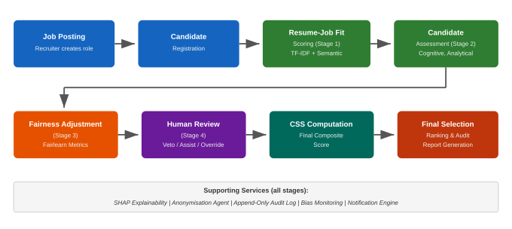
Fig 3.1 Overall Workflow of the Proposed System

3.3.4 Resume-Job Fit Scoring Process
Figure 3.2 illustrates the process flow for the resume-job fit scoring pipeline, which is the first evaluation stage. When a candidate uploads a resume, the system parses the document and extracts text content. The extracted text is then processed through two parallel paths. The first path uses TF-IDF extraction to compute a keyword presence score (S_{keyword}) that measures whether the resume contains the specific skills, qualifications, and certifications listed in the job description. The second path encodes the resume and job description into dense vector representations using the all-MiniLM-L6-v2 sentence-transformer model and computes the cosine similarity between them as a semantic alignment score (S_{semantic}). The two scores are combined into a hybrid Resume-Job Fit Score using a recruiter-configurable blending weight. A SHAP explanation is generated from the scoring features, and the system evaluates whether the score meets the screening threshold to determine if the candidate advances to the assessment stage.
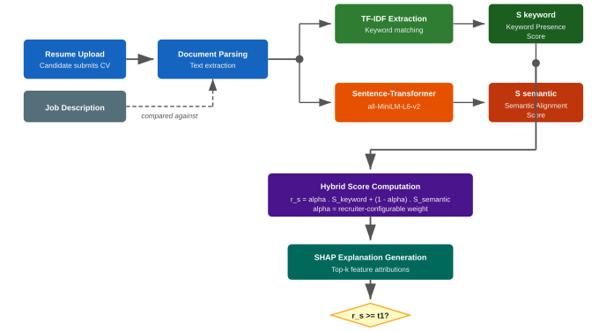
Fig 3.2 Process Flow for Resume-Job Fit Scoring

3.3.5 Stage-Based Sequential Evaluation Model
The proposed system evaluates candidates through a four-stage sequential pipeline in which each stage acts as an independent gate with its own scoring function and threshold. A candidate must pass the current gate before entering the next stage. Only candidates who clear all four gates receive a final composite score. This design prevents downstream computation on candidates who have already been filtered, reduces wasted processing, and ensures that every advancement decision is traceable to a specific, explainable metric. Figure 3.7 presents the flowchart of the stage-based sequential evaluation model.
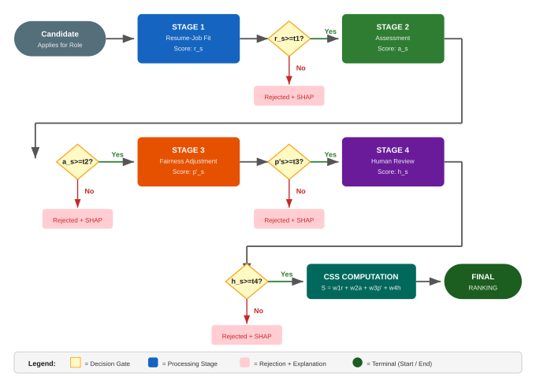
Fig 3.7 Stage-Based Sequential Evaluation Flowchart
Stage 1: Resume-Job Fit Evaluation. When a candidate applies for a position, the system evaluates whether their resume demonstrates qualification for the role. The system computes a Resume-Job Fit Score using a hybrid of keyword-level and semantic-level analysis. Let S_{keyword} denote the TF-IDF keyword presence score, which measures whether the candidate's resume contains the specific skills, qualifications, certifications, and experience terms required by the job specification. Let S_{semantic} denote the semantic alignment score, computed as the cosine similarity between the sentence-transformer embedding of the candidate's resume and the embedding of the job description. The Resume-Job Fit Score is:
r_{s} = α · S_{keyword} + (1 − α) · S_{semantic}
where α is a recruiter-configurable blending weight (default 0.4) that controls the relative importance of exact keyword presence versus contextual alignment. S_{keyword} answers the question: does this resume contain the required qualifications? S_{semantic} answers the question: does this candidate's experience contextually align with what the role demands? The candidate advances to Stage 2 if r_{s} ≥ τ₁, where τ₁ is a recruiter-set screening threshold. The decision is:
D₁ = Advance if r_{s} ≥ τ₁ ; Reject otherwise
A SHAP explanation is generated for every score, identifying the top features (skills, qualifications, experience attributes) that contributed to the candidate's r_{s} value. Rejected candidates receive a plain-language explanation derived from these features.
Stage 2: Structured Assessment. Candidates who pass Stage 1 enter a timed, proctored assessment consisting of four graded modules: Cognitive, Analytical, Communication, and Social, plus an ungraded Company-Values module. The total assessment score is:
a_{s} = aggregate score across the four graded modules
The candidate advances to Stage 3 if a_{s} ≥ τ₂, where τ₂ is a recruiter-configured assessment threshold. The decision is:
D₂ = Advance if a_{s} ≥ τ₂ ; Reject otherwise
Assessment integrity is enforced through full-screen lockdown, tab-blur detection, clipboard disabling, and periodic webcam presence verification. Integrity violations are flagged to the recruiter as advisory signals; they do not trigger automatic rejection.
Stage 3: AI Ranking with Fairness Adjustment. At this stage, a gradient-boosted model produces a raw predictive score p_{s} based on the candidate's profile features (skills, experience, assessment performance). To mitigate bias that may exist in the model's predictions, the system applies a fairness adjustment:
p'_{s} = p_{s} × (1 − δ)
where δ is a fairness penalty derived from the Fairlearn library's demographic parity ratio for the candidate's demographic group relative to the overall applicant pool. If the model scores candidates from a particular demographic group disproportionately higher or lower than others, δ adjusts the score to reduce the disparity. The candidate advances to Stage 4 if p'_{s} ≥ τ₃, where τ₃ is a recruiter-set AI ranking threshold. The decision is:
D₃ = Advance if p'_{s} ≥ τ₃ ; Reject otherwise
This stage also runs a demographic parity check and an equal opportunity check using the Fairlearn library. The results are written to the bias audit log alongside the fairness-adjusted score.
Stage 4: Human Review. Candidates who pass Stage 3 proceed to a live interview conducted within the platform over WebRTC. After the interview, an AI Interview Analyser processes the recording through speech-to-text transcription, speaker diarisation, and rubric-based scoring. The recruiter reviews the AI-generated rubric, SHAP explanations, and the interview recording, then assigns a human review score h_{s} in one of three collaboration modes:
Veto: the AI produces a recommendation, and the recruiter can only reject it, not modify it.
Assist: the AI produces a recommendation, and the recruiter makes the final decision informed by the AI's output.
Override: the recruiter makes the decision independently, and the AI audits the decision after the fact.
The candidate advances to final selection if h_{s} ≥ τ₄, where τ₄ is a recruiter-set interview threshold. The decision is:
D₄ = Advance if h_{s} ≥ τ₄ ; Reject otherwise
The collaboration mode and the recruiter's action are persisted in the audit log alongside the AI's recommendation, enabling downstream analysis of whether different collaboration modes produce different fairness profiles.
Final Composite: Candidate Suitability Score (CSS). For candidates who pass all four stage gates, the system computes a Candidate Suitability Score as a weighted composite:
S_{final} = w₁ · r_{s} + w₂ · a_{s} + w₃ · p'_{s} + w₄ · h_{s}
where w₁ through w₄ are recruiter-configurable weights constrained such that ∑w_{i} = 1. The CSS is not computed for the full applicant pool. It applies only to the subset of candidates who have demonstrated competence at every stage, which means the final ranking reflects verified qualification rather than a single early-stage prediction. Finalists are ranked by S_{final} in descending order, and a per-candidate natural-language justification is generated from the top-k SHAP features aggregated across all four stages.

3.4 Objectives of the Proposed System
The proposed system, Integra-Hire, is designed to achieve the following objectives:
i. To develop an AI-driven recruitment system that integrates resume screening, candidate assessment, interview analysis, and final selection within a single platform while maintaining fairness monitoring, explainability, and human oversight at every stage.
ii. To implement a stage-based sequential evaluation model in which each recruitment stage acts as an independent gate with its own scoring function, threshold, and SHAP-based explanation, ensuring that every advancement or rejection decision is traceable and auditable.
iii. To integrate a fairness adjustment layer that uses the Fairlearn library to compute demographic parity and equal opportunity metrics, applying real-time score adjustments during the AI ranking stage rather than relying solely on post-hoc auditing.
iv. To provide a structured human-AI collaboration framework through three configurable modes (Veto, Assist, and Override) that record the recruiter's level of involvement in every AI-assisted decision, enabling analysis of how different collaboration modes affect fairness outcomes.

3.5 Design Approach for the Proposed System
The proposed system follows a modular architecture composed of fifteen discrete modules, each responsible for a specific function within the recruitment pipeline. The architecture is organised into four layers: the presentation layer (React single-page application), the application layer (Node.js API with MongoDB and Redis), the AI/ML layer (Python FastAPI microservice), and the data layer (MongoDB, Redis, Protected Attributes Store). This section describes the design approach for each major pipeline of the system.
i. Resume-Job Fit Evaluation Pipeline. The resume screening pipeline receives a candidate's uploaded resume and the job specification from the application layer. The pipeline passes both documents to the AI/ML layer, where two parallel computations occur. The TF-IDF branch tokenises both documents, builds term-frequency vectors, and computes a keyword presence score that measures whether the resume contains the specific skills, certifications, and qualifications listed in the job specification. The sentence-transformer branch encodes both documents into dense vector representations using the all-MiniLM-L6-v2 model and computes the cosine similarity between them as a semantic alignment score. The two scores are combined using the recruiter-configurable blending weight to produce the Resume-Job Fit Score. A SHAP explanation is generated from the scoring features, and the score, explanation, and decision (advance or reject) are written to the audit log.
ii. Assessment Pipeline. The assessment pipeline presents candidates who pass the resume screening gate with a timed, proctored online test. The test consists of four graded modules (Aptitude, Technical, Situational, and Personality) and one ungraded module (Company Values). Each module contains a configurable number of questions, and the system records accuracy, time per question, and section-level aggregate scores. Proctoring integrity is enforced through full-screen lockdown, tab-blur detection, clipboard disabling, and periodic webcam presence checks using the browser's MediaDevices API. Integrity violations are flagged to the recruiter as advisory signals rather than automatic disqualifications, preserving human judgment in ambiguous cases. The aggregate assessment score is compared against the recruiter-configured threshold to determine whether the candidate advances to the fairness adjustment stage.
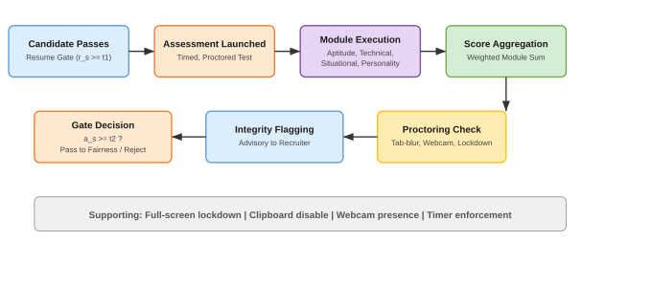
Fig 3.3 Process Flow Diagram for Assessment Pipeline
iii. Fairness Adjustment Pipeline. The fairness pipeline operates on candidates who pass the assessment gate. A gradient-boosted model produces a raw predictive score from the candidate's feature vector (skills, experience, assessment performance). The Fairlearn library then computes demographic parity and equal opportunity metrics for the current candidate pool, comparing score distributions across protected demographic groups. If a disparity is detected, a fairness penalty is derived and applied to the raw score, producing a fairness-adjusted score. The protected attributes used for this computation (gender, ethnicity, age, disability status) are stored in a logically isolated collection that is accessible only to the anonymisation agent and the bias audit module. The AI scoring models never receive raw protected attributes; the anonymisation agent masks them before any candidate data reaches the scoring pipeline. This is a structural guarantee against direct discrimination: the ranker cannot discriminate on an attribute it was never given.
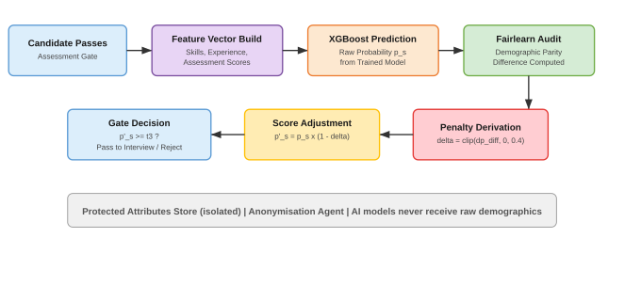
Fig 3.4 Process Flow Diagram for Fairness Adjustment Pipeline
iv. Human-AI Collaboration Pipeline. The human review pipeline structures the recruiter's involvement in every AI-assisted decision through three configurable modes. In Veto mode, the AI produces a recommendation and the recruiter can only reject candidates the AI has advanced; the recruiter cannot promote candidates the AI has rejected. In Assist mode, the AI produces a recommendation with SHAP explanations and the recruiter makes the final decision, informed by but not bound to the AI's output. In Override mode, the recruiter makes the decision independently without seeing the AI's recommendation, and the AI audits the decision after the fact by comparing the recruiter's choice against what the model would have recommended. The collaboration mode selected for each decision, along with the recruiter's action and the AI's original recommendation, is persisted in the audit log. This enables downstream analysis of whether different collaboration modes produce systematically different fairness outcomes, which is a research question that no existing platform provides the data to answer.
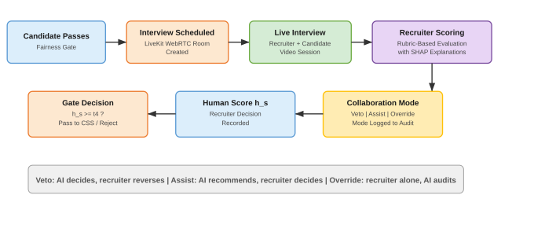
Fig 3.5 Process Flow Diagram for Interview and Human Review Pipeline
v. Explainability Pipeline. The explainability pipeline generates feature-level explanations for every AI-produced score at every stage of the evaluation. For the resume-job fit score, SHAP identifies which skills, qualifications, and experience terms contributed most to the candidate's score. For the assessment score, explanations link performance to specific module-level metrics. For the fairness-adjusted score, SHAP identifies the features driving the raw predictive model, and the fairness adjustment is reported separately so that the recruiter can distinguish between the model's prediction and the fairness correction. For the interview score, SHAP attributes are generated from the rubric-based scoring features. Candidate-facing explanations use a plain-language template filled from the top-k SHAP features, avoiding technical jargon while preserving the substance of the explanation. Because explanations are generated from the same features used in scoring, they are faithful by construction.
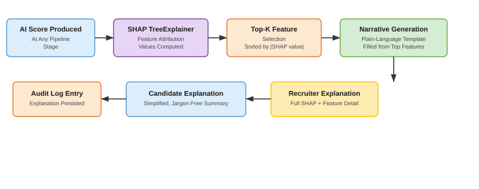
Fig 3.6 Process Flow Diagram for Explainability Pipeline
vi. Interview Pipeline. The interview pipeline provides a live, WebRTC-based interview room where the recruiter and candidate interact in real-time. The session is recorded, and after the interview, the AI Interview Analyser processes the recording through speech-to-text transcription, speaker diarisation (separating recruiter and candidate speech), and rubric-based scoring against the criteria defined for the role. The recruiter reviews the AI-generated rubric scores, the SHAP explanations for those scores, and the interview recording, then assigns a human review score in the collaboration mode selected for that job. The interview pipeline is the stage where human judgment is most directly exercised, and the Veto/Assist/Override framework ensures that the mode and extent of that judgment are recorded for every decision.
vii. Audit and Compliance Pipeline. The audit pipeline records every AI output, recruiter decision, fairness computation, and SHAP explanation to an append-only log. No process in the system overwrites a previous entry. This produces a chronological record that supports regulatory compliance with frameworks such as the EU AI Act and the Nigeria Data Protection Regulation (NDPR), enables the bias audit module to compute fairness trends over time, and provides the evidentiary basis for any internal or external review of the system's decision-making. Protected attributes are stored in a logically separated collection and are never exposed to the AI scoring models, ensuring that the audit trail can demonstrate structural separation between sensitive data and scoring logic.

3.6 Justification of the New System
The proposed system is justified by the five problems identified in Section 3.2 and the inability of any existing platform to address them within a single architecture. Against the absence of integrated fairness monitoring, the system embeds demographic parity and equal opportunity computation at Stage 3 of the evaluation pipeline with real-time score adjustment, rather than relegating fairness to a post-hoc reporting dashboard. Against the opacity of AI decisions, the system generates SHAP-based feature-level explanations for every score at every stage, providing both recruiter-facing and candidate-facing transparency. Against the lack of structured human-AI collaboration, the system implements the Veto, Assist, and Override framework and records the collaboration mode in the audit log alongside every decision. Against functional fragmentation, the system provides an end-to-end pipeline that moves from job posting through screening, assessment, fairness-adjusted ranking, interview, and final selection within a single platform. Against the absence of context-appropriate solutions for Nigeria, the system is designed with NDPR compliance as an architectural concern, targets English-language resumes in the Nigerian market, and is built for deployment in the local recruitment context.
The justification is not that the proposed system introduces novel machine learning algorithms; it does not. The justification is that it integrates existing, proven components (sentence-transformers, Fairlearn, SHAP, LIME) within an architecture that structurally enforces fairness, explainability, and human oversight at every decision point, which is something no existing system does.

3.7 System Design
This section presents the system design of Integra-Hire through standard software engineering diagrams. The system flowchart illustrates the stage-based evaluation process, and the Unified Modelling Language (UML) diagrams capture the system's use cases, activity flows, and class structure.

3.7.1 System Flowchart
The system flowchart for Integra-Hire was presented in Figure 3.7 within the stage-based sequential evaluation model (Section 3.3.4). The flowchart depicts the candidate's journey through four sequential gates: resume-job fit evaluation, structured assessment, AI ranking with fairness adjustment, and human review. At each gate, a decision diamond tests the candidate's score against the recruiter-configured threshold. Candidates who meet the threshold advance to the next stage, while candidates who do not meet the threshold are rejected with a SHAP-generated explanation. Candidates who clear all four gates proceed to the CSS computation, which produces the final ranking.

3.7.2 Unified Modelling Language (UML) Diagrams

Use Case Diagram
Figure 3.8 presents the use case diagram for Integra-Hire, showing the interactions between the three primary actors (Candidate, Recruiter, and Admin) and the system's major functions. The Candidate actor interacts with the system through registration, resume upload, assessment completion, interview participation, and the viewing of results and SHAP-generated explanations. The Recruiter actor posts jobs, screens candidates, sets scoring thresholds, conducts interviews, selects the collaboration mode for each decision, and views the audit log. The Admin actor manages users, configures system settings, and views bias reports generated by the fairness auditor.
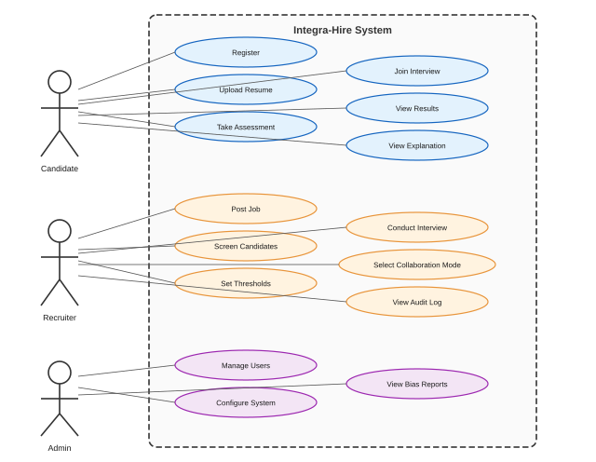
Fig 3.8 Use Case Diagram

Activity Diagram
Figure 3.9 presents the activity diagram for the candidate evaluation workflow. The diagram traces the flow from the point a candidate submits an application through resume parsing, score computation, and each decision gate. At every decision point, the "No" path leads to the generation of a SHAP explanation followed by candidate notification and process termination. The "Yes" path advances the candidate to the next stage. Candidates who pass all four gates proceed to CSS computation and final ranking. This diagram complements the flowchart in Figure 3.7 by showing the activity-level detail of each step, including the rejection-with-explanation path that ensures transparency even for unsuccessful candidates.
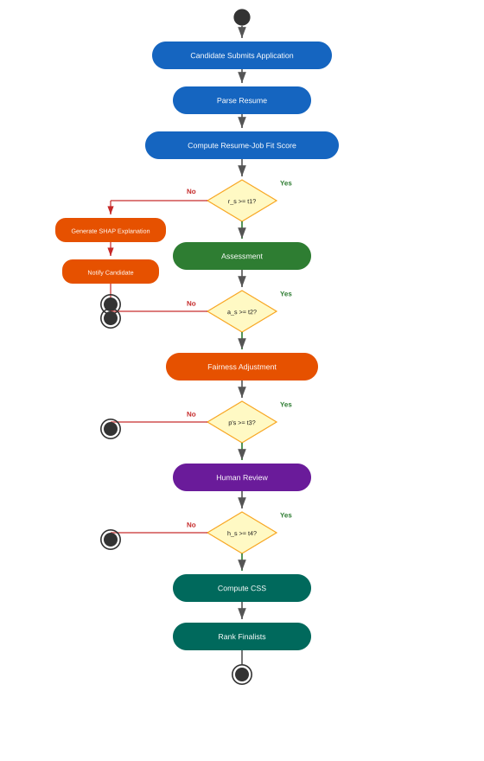
Fig 3.9 Activity Diagram

Class Diagram
Figure 3.10 presents the class diagram for the core data model of Integra-Hire. The diagram shows six classes and their relationships. The User class stores candidate, recruiter, and admin account information. The Job class represents a posted position with its requirements and scoring thresholds. The Application class links a candidate to a job and tracks the candidate's status and scores through each evaluation stage. The Assessment class records module-level scores for a given application. The AuditLog class provides an append-only record of every AI score, human score, and collaboration mode for each stage of a given application. The BiasReport class stores the fairness metrics computed by the Fairlearn-based auditor for each job. The relationships are: a User may have many Applications, a Job may have many Applications, each Application has exactly one Assessment, each Application may have many AuditLog entries, and each Job may have many BiasReports.
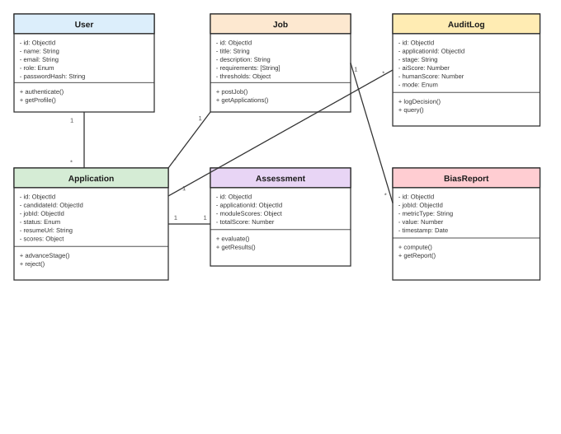
Fig 3.10 Class Diagram

3.8 System Requirements

3.8.1 Hardware Requirements
Table 3.1 presents the minimum and recommended hardware requirements for deploying Integra-Hire on a server environment. The client environment requires a modern web browser (Chrome, Firefox, Edge, or Safari) with WebRTC support, a webcam and microphone for assessment proctoring and live interviews, and a minimum display resolution of 1280 by 720 pixels.

Component | Minimum Requirement | Recommended Requirement
Processor | Intel Core i5 / 4 cores | Intel Core i7 / 8 cores
RAM | 16 GB | 32 GB
Storage | 100 GB SSD | 256 GB SSD
Network | Stable broadband (10 Mbps) | High-speed (50+ Mbps)
Display | 1280 x 720 | 1920 x 1080
Webcam / Microphone | Required for proctoring | HD webcam recommended

Table 3.1 Hardware Requirements

3.8.2 Software Requirements
The software requirements for Integra-Hire are organised by category below.
Server-Side
Node.js 18+ with Express for the API server
MongoDB 6+ for the primary database
Redis for job queuing and session caching
Python 3.10+ with FastAPI for the AI microservice
AI/ML Libraries
sentence-transformers (all-MiniLM-L6-v2) for semantic encoding
scikit-learn for TF-IDF computation and gradient boosting
Fairlearn for demographic parity and equal opportunity computation
SHAP for feature-level explainability
LIME for complementary model-agnostic explanations
Client-Side
React 18 with TypeScript for the single-page application
WebRTC (mediasoup or LiveKit) for live interview rooms
Socket.IO for real-time communication
Security
JWT with short-lived access tokens and rotating refresh tokens
TLS encryption for all data in transit
bcrypt for password hashing
DevOps
Docker for containerised deployment across environments
Git for version control

